Movie Ticket Booking System
A menu-driven C++ console application demonstrating Object-Oriented
Analysis, Low-Level Design and System Design principles

Problem Statement
Build a small movie ticket booking system for a single cinema, as a menu-driven C++ console program. A customer should be able to see which movies are playing, pick a show, see which seats are free, book seats, pay, get a ticket, and cancel a booking.
The system implements 8 required features (F1–F8): listing movies, listing shows, displaying the seat layout, booking seats (rejecting already-booked seats), pricing by seat type, accepting UPI / Card / Cash payment (a failed payment must not confirm the booking), printing a ticket, and cancelling a booking.

Item A — Requirement Analysis

A.1 Functional Requirements
ID | Functional Requirement
FR1 | Movie listing: On selecting the “Movies” menu option, the system displays every movie currently playing, showing at least its title, language and duration. If no movies exist, the system shows an empty list message instead of crashing.
FR2 | Show listing: After a customer selects a movie, the system lists only the shows belonging to that movie, each showing its screen number and start time. Choosing an option outside this list is rejected with a clear message and no state change.
FR3 | Seat layout: After a show is selected, the system displays every seat of that show, each marked AVAILABLE “[ ]” or BOOKED “[X]”, before any seat number is accepted from the customer.
FR4 | Booking: a customer selects one or more seat numbers for a show. If any selected seat is already BOOKED, the whole booking is rejected and no seat changes state. Booking is confirmed only after payment succeeds.
FR5 | Price calculation: the system calculates the booking amount by summing each selected seat’s type-based price (SILVER ₹150 / GOLD ₹250 / PLATINUM ₹400). The customer never types in a price directly.
FR6 | Payment: exactly one method (UPI / Card / Cash) per booking. If payment fails, the previously held seats are released back to AVAILABLE and the booking status becomes FAILED.
FR7 | Ticket printing: once a booking is CONFIRMED, the system prints a ticket containing the booking id, movie title, screen, show time, all booked seat numbers and the total amount. Nothing is printed if payment failed.
FR8 | Cancellation: given a CONFIRMED booking id, the system marks that booking CANCELLED and releases every seat in it back to AVAILABLE. Cancelling an unknown id, or a booking that is not CONFIRMED, is rejected with a message.

A.2 Non-Functional Requirements
NFR | Requirement | How it is addressed
NFR1 | Modularity | One class per .cpp file (Movie, Seat, Screen, …, BookingService each in their own file, no header files), so each file has a single, findable responsibility.
NFR2 | Extensibility | Adding a new payment method (e.g. NetBanking) only requires a new subclass of the abstract Payment class — BookingService and Booking are never edited (Open/Closed Principle).
NFR3 | Input validation | Every menu choice, movie/show index, seat number and payment amount is checked before use; invalid input prints a message and returns to the menu instead of crashing.
NFR4 | Maintainability | Booking, pricing, payment and printing responsibilities are separated into different classes (Booking, PriceCalculator, Payment hierarchy, TicketPrinter) so a change to one rule does not touch unrelated code.

Item B — Noun–Verb Analysis
Nouns and verbs identified directly from the problem statement in Section 1, decided against whether each noun deserves to be its own class.

B.1 Nouns Identified
Noun | Keep as class? | Reason
Movie | Yes | Has its own identity and data (title, language, duration) independent of any show.
Seat | Yes | Has its own number and type (SILVER/GOLD/PLATINUM); physically exists in a screen regardless of any show.
Screen | Yes | Represents one physical auditorium; owns a fixed set of seats.
Cinema | Yes | Represents the theatre; owns multiple screens.
Show | Yes | A specific screening = a Movie on a Screen at a given time; needs its own id and time.
ShowSeat | Yes | Stores the AVAILABLE/BOOKED status of one seat for one specific show — that status differs per show, so it cannot live on Seat itself.
Customer | Yes | Represents the person making a booking; has name and phone.
Booking | Yes | Represents one reservation transaction: id, seats, amount, status.
Payment | Yes | Represents the act of paying; varies by method, so modelled as an abstract class with concrete subclasses.
Ticket | No | Not a class with its own state — it is only a printed representation of an existing Booking, produced by TicketPrinter.
Seat layout | No | A view over a Show’s ShowSeats, not an independent object — implemented as Show::printSeatLayout().
Title / Language / Duration | No | These are attributes of Movie, not classes of their own.
Seat number / Seat type | No | Attributes of Seat.
Start time | No | An attribute of Show (showDateTime).
Status (AVAILABLE/BOOKED, or booking status) | No | A state/value represented as an enum (Status, BookingStatus), not an independent object.
Booking id / Amount | No | Attributes of Booking, generated/calculated rather than separate classes.

B.2 Verbs Identified → Candidate Methods
Verb (from problem statement) | Becomes method(s) on
see / list movies | Cinema/main → lists movies (F1)
pick a show | Movie/main → lists Show objects for a movie (F2)
see which seats are free / display | Show.printSeatLayout(), ShowSeat.isAvailable() (F3)
book seats | BookingService.bookSeats(), ShowSeat.book() (F4)
calculate / price | PriceCalculator.calculateTotal() (F5)
pay | Payment.pay() — overridden by UpiPayment/CardPayment/CashPayment (F6)
print / generate ticket | TicketPrinter.printTicket() (F7)
cancel | BookingService.cancelBooking(), Booking.cancel(), ShowSeat.release() (F8)

Item C — Relationship Table (with the lifetime test)
For every pair, the choice is justified by asking: “if the whole is destroyed, does the part die with it?” If yes → composition. If the part survives independently → aggregation. If neither owns the other → association. “Is-a” → inheritance.
Pair | Relationship | Justification (lifetime test)
Cinema — Screen | Composition (◆) | Screens are created and owned by the Cinema in this system; if the Cinema object is destroyed, its Screens have no independent existence and are destroyed with it.
Screen — Seat | Composition (◆) | A physical Seat belongs to exactly one Screen; destroying the Screen destroys its Seats — a seat cannot be moved to another screen.
Show — Movie | Aggregation (◇) | A Show borrows a Movie. Cancelling the 6 PM show does not delete the movie “3 Idiots” — it still exists and still plays at 9 PM. The Show only stores a pointer/reference.
Show — Screen | Aggregation (◇) | A Show borrows a Screen. Removing that one show does not destroy Screen-1 — the screen still exists and can host the 9 PM show.
Show — ShowSeat | Composition (◆) | ShowSeats are created fresh for that specific Show and have no meaning outside it; when the Show is removed, its ShowSeats are removed with it.
Booking — Customer | Association (→) | A Booking is made by a Customer, but neither owns the other. The Customer exists before and after the booking and can make many other bookings independently.
Booking — ShowSeat | Aggregation (◇) | A Booking references existing ShowSeats it did not create. Cancelling/destroying a Booking must NOT delete the ShowSeat — it only flips the ShowSeat’s status back to AVAILABLE.
Booking — Payment | Composition (◆) | A Payment record is created only for that one Booking and is meaningless without it; when that Booking object is destroyed, its Payment is destroyed with it.
Payment — UpiPayment | Inheritance (▷) | UpiPayment IS-A Payment — it inherits the pay(amount) contract and supplies its own implementation (also true for CardPayment, CashPayment).
BookingService — Booking | Composition (◆) | BookingService creates every Booking (via «create») and owns its lifetime in its own list; no other class ever creates a Booking.

Item D — Class Diagram
The diagram below contains every class from Step C, with three compartments (name / attributes / methods), visibility markers (− private, # protected, + public), correct UML notation (filled diamond = composition, hollow diamond = aggregation, open arrow = association, hollow triangle = inheritance) and multiplicities on every structural relationship. The Payment hierarchy is marked «abstract» on its base class.
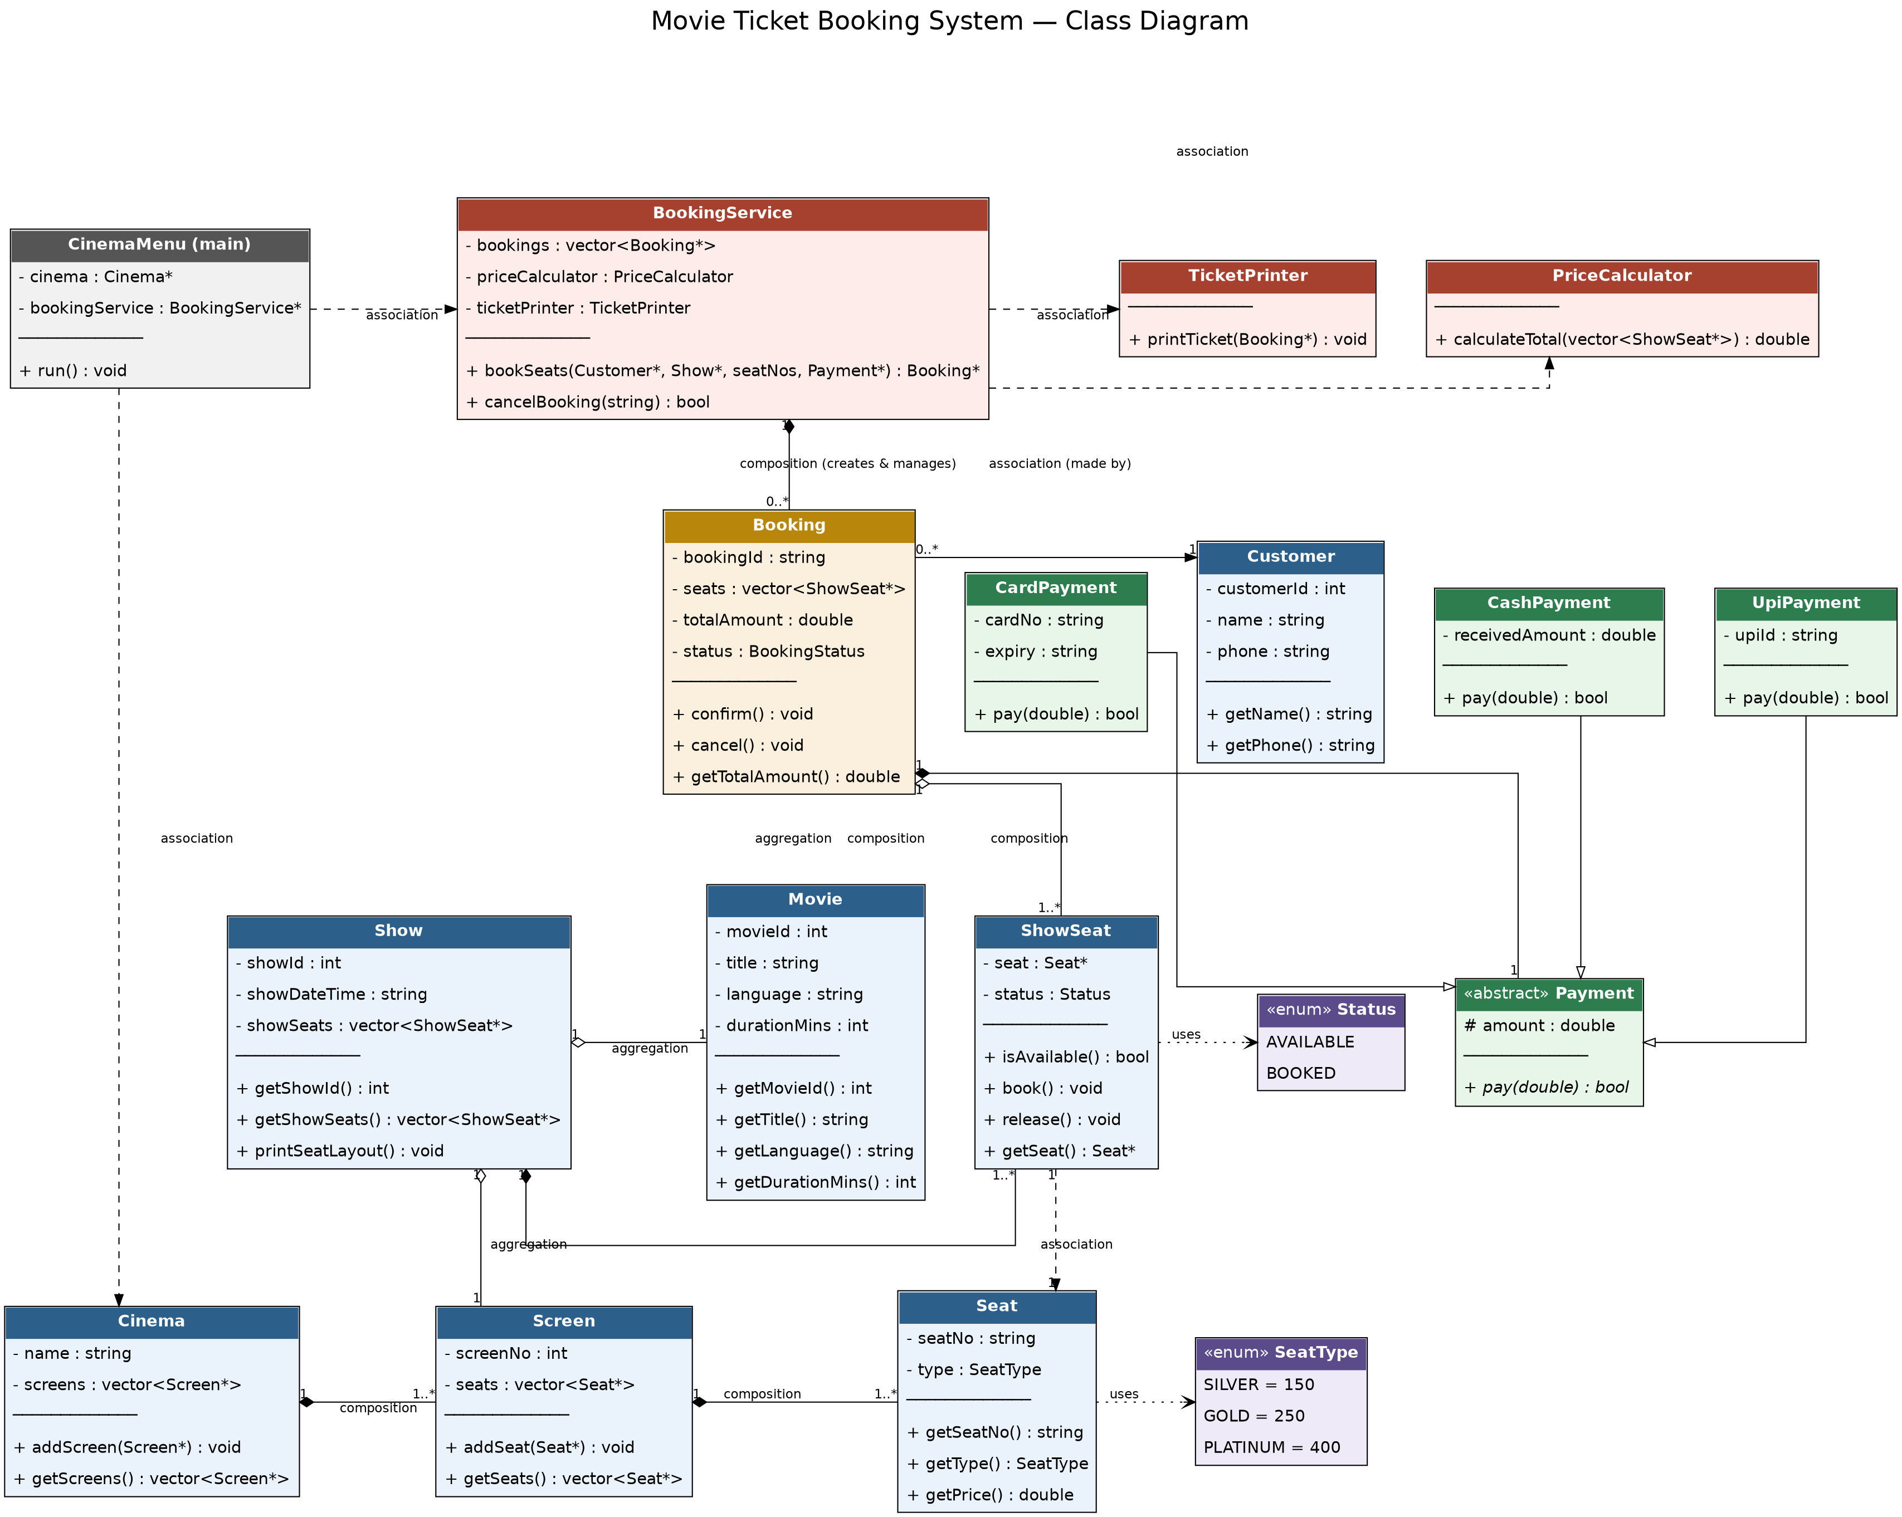

Item E — Sequence Diagram
Use case: “customer books 1 seat and pays by UPI”, from choosing a show to the ticket being printed. Lifelines shown: Customer, CinemaMenu, BookingService, Show, ShowSeat, PriceCalculator, Booking, Payment and TicketPrinter, with activation bars, synchronous calls, return messages and «create» messages for the Booking and Payment objects.
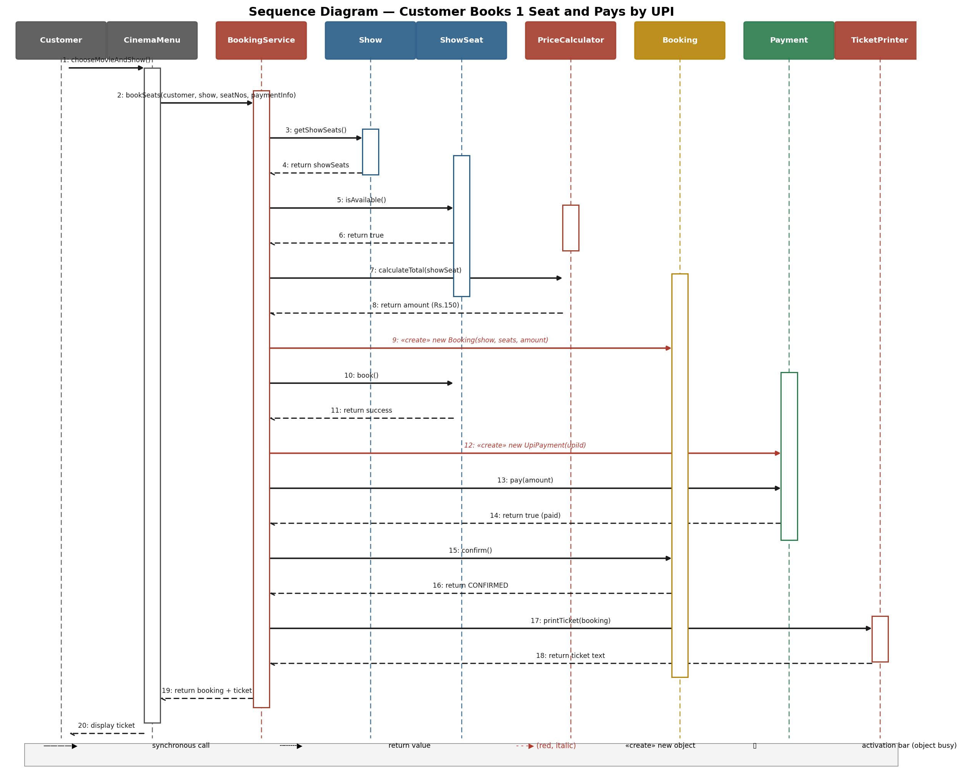

Item F — Modular Working Code + Demo Run
The full C++ source (submitted as separate files, one class per file, no header files, matching the suggested file structure in the assignment) is included alongside this document:
- 01_Movie.cpp, 02_Seat.cpp, 03_Screen.cpp, 04_Cinema.cpp, 05_Show.cpp, 06_ShowSeat.cpp
- 07_Customer.cpp, 08_Booking.cpp, 09_Payment.cpp, 10_PaymentTypes.cpp
- 11_PriceCalculator.cpp, 12_TicketPrinter.cpp, 13_BookingService.cpp, main.cpp
Compile and run with:
g++ -std=c++17 -o booking main.cpp && ./booking

Item G — SOLID Mapping + What Was Deliberately Not Done
Principle | Where it is applied in this system
S — Single Responsibility | Booking only holds booking data and status — it does NOT calculate price (that is PriceCalculator’s job) and does NOT print tickets (TicketPrinter’s job). A change to the ticket’s layout only touches TicketPrinter.
O — Open/Closed | Adding a new payment method (e.g. NetBankingPayment) only needs a new subclass of Payment. BookingService.bookSeats() is never modified because it calls payment->pay() through the abstract Payment interface.
L — Liskov Substitution | Any Payment* — UpiPayment, CardPayment or CashPayment — can be passed into bookSeats() and called via pay() with no special-casing; BookingService never checks “if this is a CardPayment do X instead.”
D — Dependency Inversion | BookingService depends on the abstract Payment class (an abstraction), never on a concrete UpiPayment/CardPayment/CashPayment. The concrete class is chosen by main.cpp’s menu, not by BookingService.

One thing deliberately NOT done
Interface Segregation was intentionally not forced onto the Payment hierarchy: a separate Refundable interface with a refund() method was NOT added, because refunds are outside this assignment’s scope (“build exactly this, nothing more”). Forcing refund() onto UpiPayment/CardPayment/CashPayment when nothing in the system calls it would be speculative generality (YAGNI), not good design. Similarly, no file/database persistence was added — all data is kept in memory for the duration of one run, matching the console-only scope of the assignment.

Clean Code Checklist
- Intention-revealing names — bookingId, totalAmount, showSeats (no bsc, c1, temp1).
- No number-series names anywhere in the code.
- Every function does one thing (findSeats(), calculateTotal(), printTicket() are each single-purpose).
- No function longer than ~20 lines.
- Constants instead of magic numbers — SILVER_PRICE, GOLD_PRICE, PLATINUM_PRICE.
- No side effects — printSeatLayout() and calculateTotal() never modify booking state.
- No repeated code — pricing logic lives only in PriceCalculator, printing logic only in TicketPrinter.

